NGT Practical

Practical 1:

1. Write a MongoDB

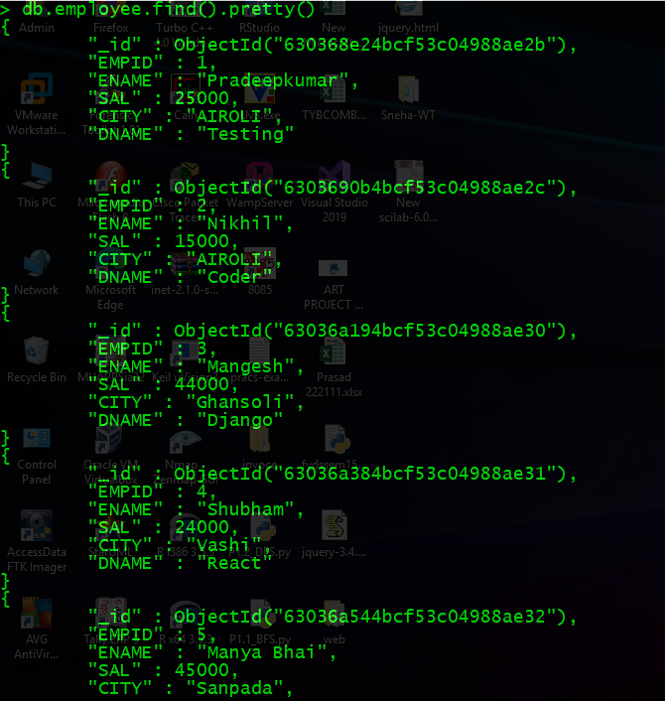

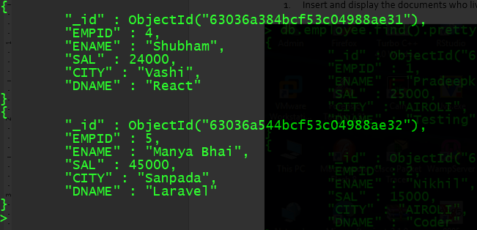

1. 2) Insert and display the documents who live in mulund.

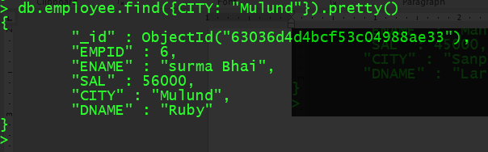

3) Display details of employees staying in dadar and salary greater than 5000.

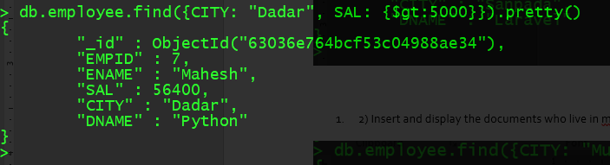

4) Display details of the employee whose salary is greater than equal 5000 but less than 10000.

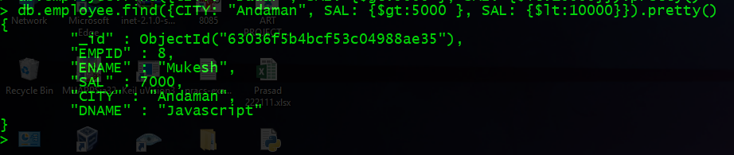

5) Display details of employees staying in either thane or mulund and salary greater than 5000.

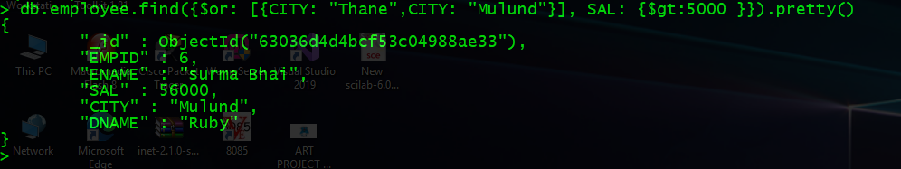

6) Display details of employee whose salary is not equal to 5000 and working in either testing or sales department.

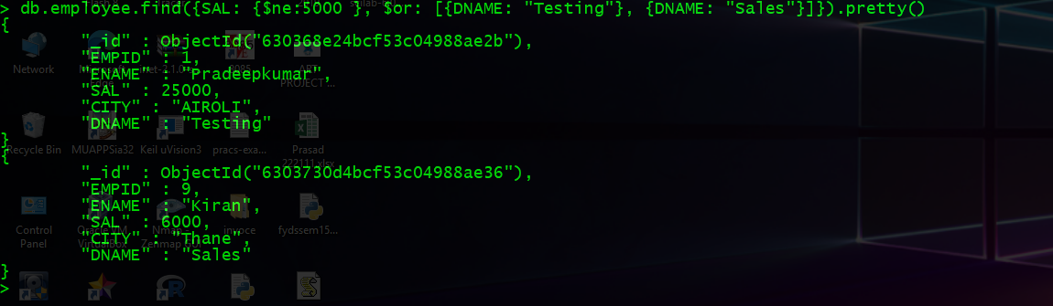

Practical 2:

1. Write a MongoDb query to display all the documents in the collection Employee.

